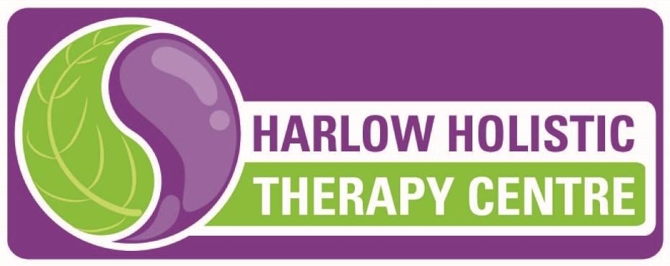

Permission from Local Health Authority to open during current Lock-Down
Dear Owner
of the Harlow Holistic Therapy Centre, 2 Slacksbury Hatch, Hare Street, Harlow CM19 4EU
I can confirm that your premise is permitted to remain open during the current lockdown period under the above regulation and current guidance undertaking the following treatments:

• Body Mechanics Therapy (pain relief treatment)
• Kinesiology (pain relief treatment)
• Reflexology (pain relief treatment)

All non-pain relief and beauty treatments must cease.
Your business has undertaken a COVID risk assessment and put satisfactory safety procedures in place.
Kind regards

Steven Adams
Senior Environmental Health Officer
Environmental Health

PLEASE NOTE – NO WALK-INS ALLOWED – TREATMENTS BY APPOINTMENT ONLY AND SUBJECT TO MEETING STRICT APPROVED CRITERIA. WE RESERVE THE RIGHT TO REFUSE TREATMENT IF THE SET CRITERIA IS NOT MET. NORMAL THERAPY WILL RESUME FOLLOWING THE LOCK-DOWN. THIS IS A TEMPORARY MEASURE TO ENSURE THOSE IN PAIN CAN RECEIVE THE NECESSARY THERAPY.
WE APPRECIATE YOUR CO-OPERATION

